Role based Access:
Case 1:
Admin User with full access:

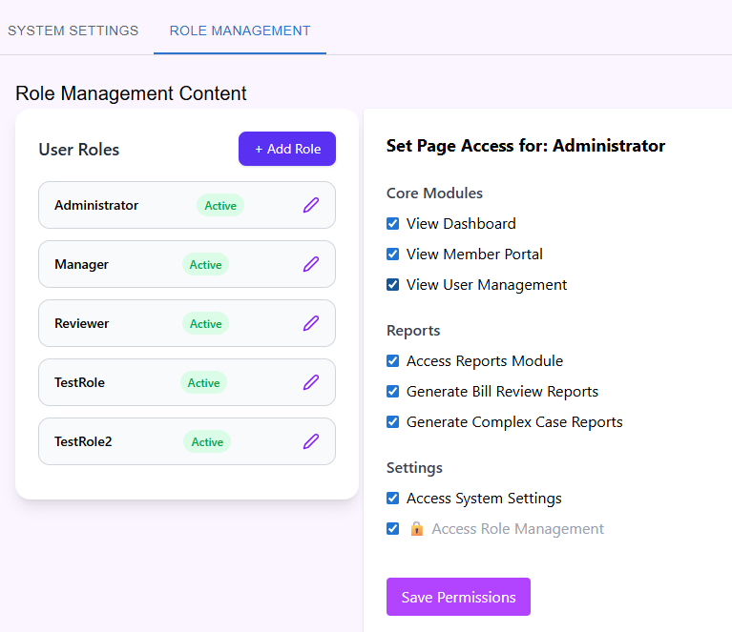
Click Save Permission and logout the system.
Output:
Login with Admin User:
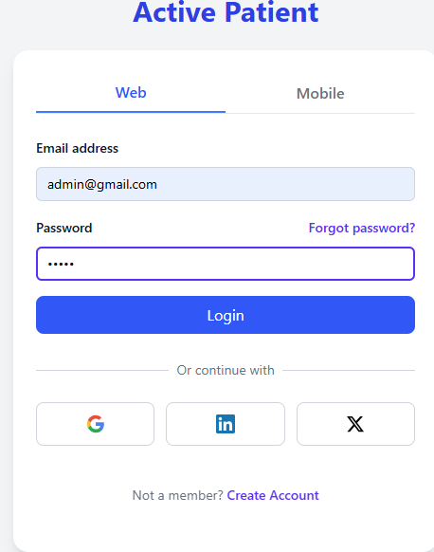
Menu Bar:
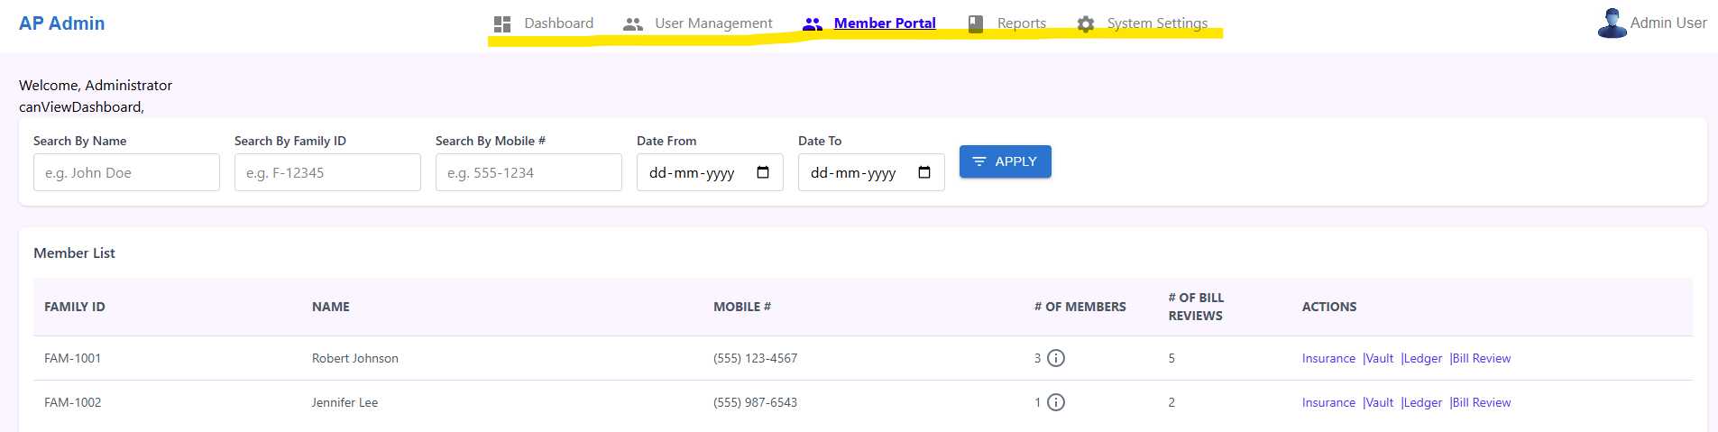

Case 2:
Admin User with Partial access(Removed user portal and Report access)
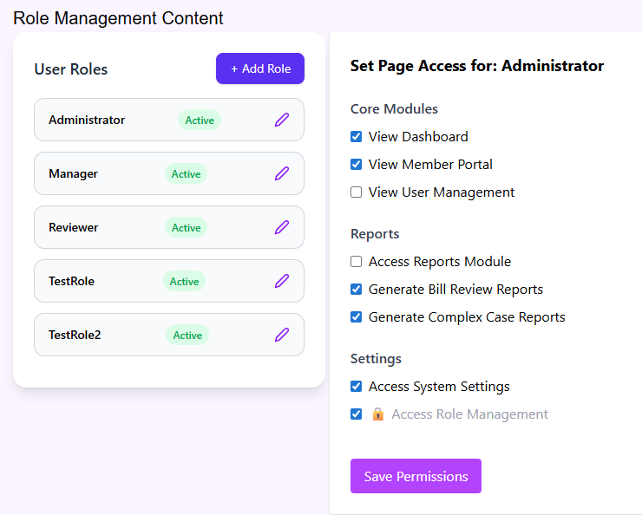
Login again.
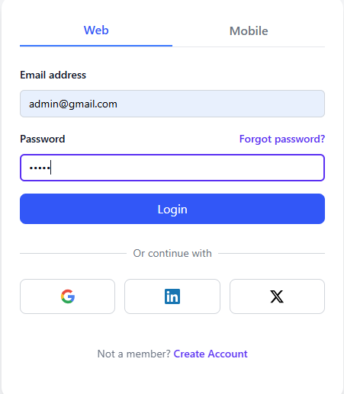
Menu Bar:
TOP Bar displayed with Dashboard, Member Portal and System access Module.
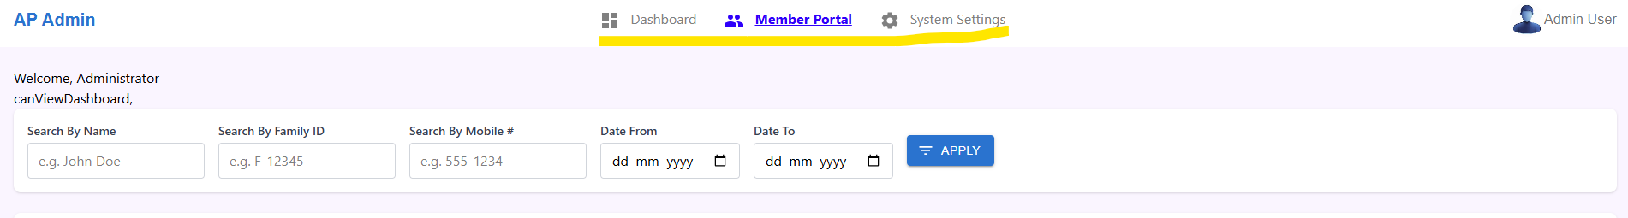
Even user try to access user-module (Which don’t have access) in address bar
